Monday February 26
Post 1:
Happy Monday everyone!
This week marks the start of National Invasive Species Awareness Week, and we need your help to spread the word. Join us in preserving the biodiversity of our beautiful planet and learn what you can do to prevent the spread of invasive species. #NationalInvasiveSpeciesAwarenessWeek

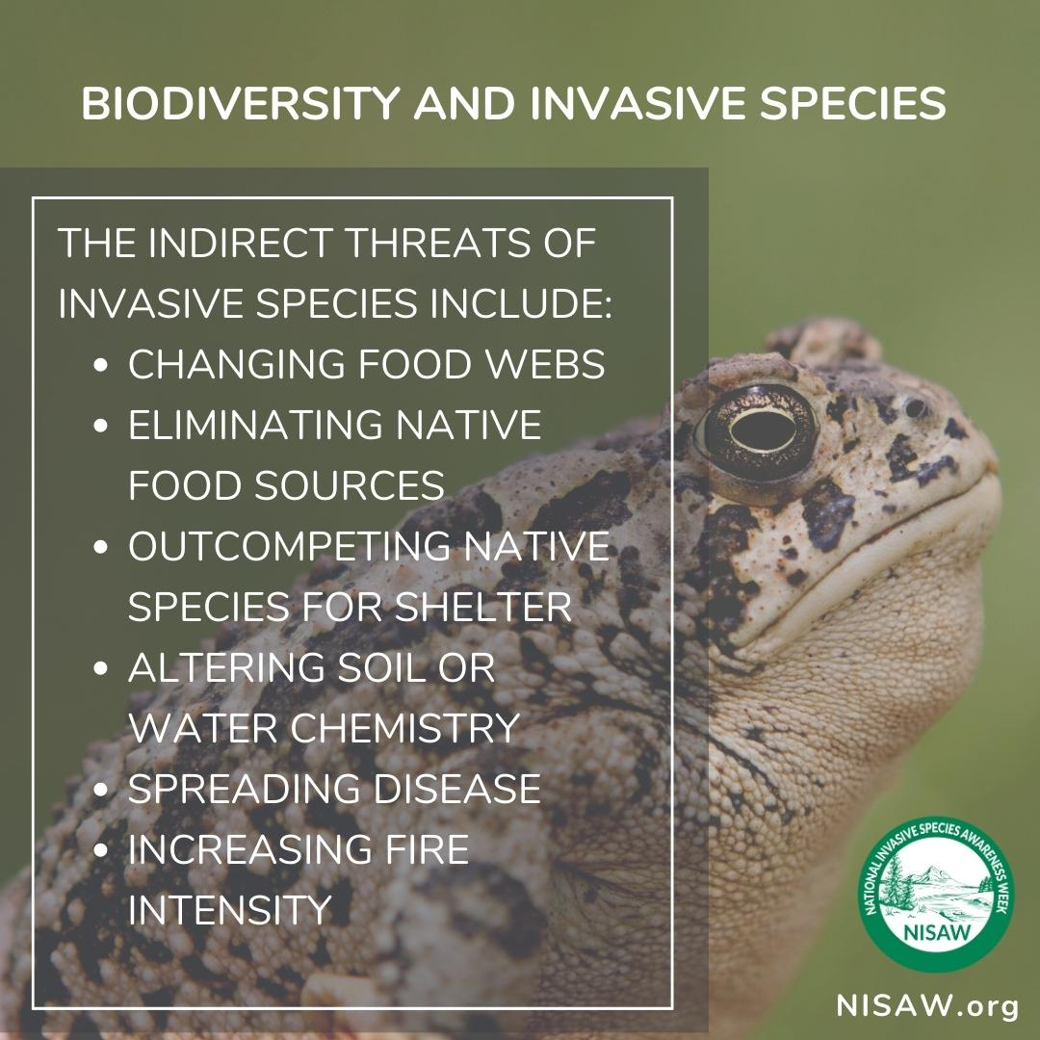

Post 2:
Watch List, Prohibited, Restricted Species
As a CISMA it is our mission to help protect our Great Lakes and natural habitats protected through education and spreading awareness of invasive species that threaten these ecosystems. The State of Michigan designates some species as prohibited, restricted, and/or watch-list species. The Michigan Invasive Species Watchlist contains species that pose an immediate or potential threat and could spread quickly if introduced. If a species is prohibited or restricted, it is unlawful to possess, introduce, import, sell or offer that species for sale as a live organism, except under certain circumstances. The term "prohibited" is used for species that are not widely distributed in the state. Often, management or control techniques for prohibited species are not available. The term "restricted" is applied to species that are established in the state. Management and control practices are usually available for restricted species (Michigan.gov/invasives).

Below is a link to MISIN, the Midwest Invasive Species Information Network with Michigan invasive species resources, invasive species contacts, and lists the species that are prohibited restricted and watch list.
#NatioanlInvasiveSpeciesAwarenessWeek #ProtectMichiganLakes

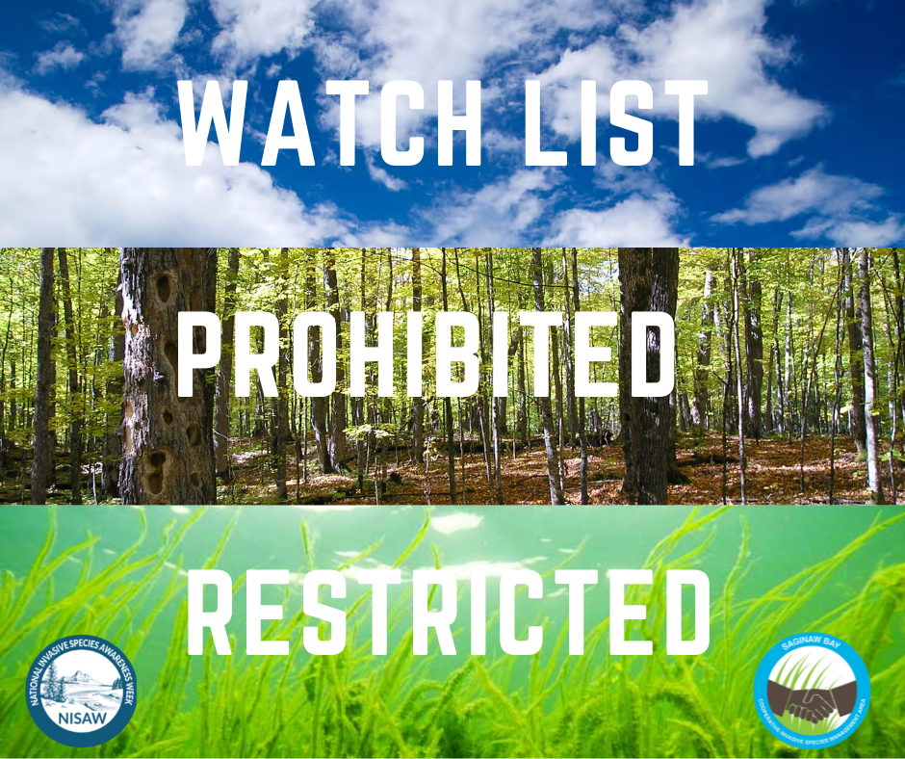
https://www.misin.msu.edu/states/michigan/

Tuesday February 27
Post 1:
Protect our Great Lakes from AIS!
Aquatic invasive species (AIS) are a growing threat to the health and sustainability of our beloved Great Lakes. These non-native plants and animals, often introduced through human activities, have the ability to outcompete native species, alter ecosystems, and cause harm to the fishing, boating, and tourism industries. The impact of invasive species on the Great Lakes has been an ongoing issue, with some estimates putting the cost of control and management in the hundreds of millions of dollars annually. Later this week, we will be sharing in more detail simple practices to follow when entering any waterbody in Michigan to prevent the spread of invasive species: stay tuned! #NationalInvasiveSpeciesWeek #CleanDrainDry #StopAquaticHitchhikers

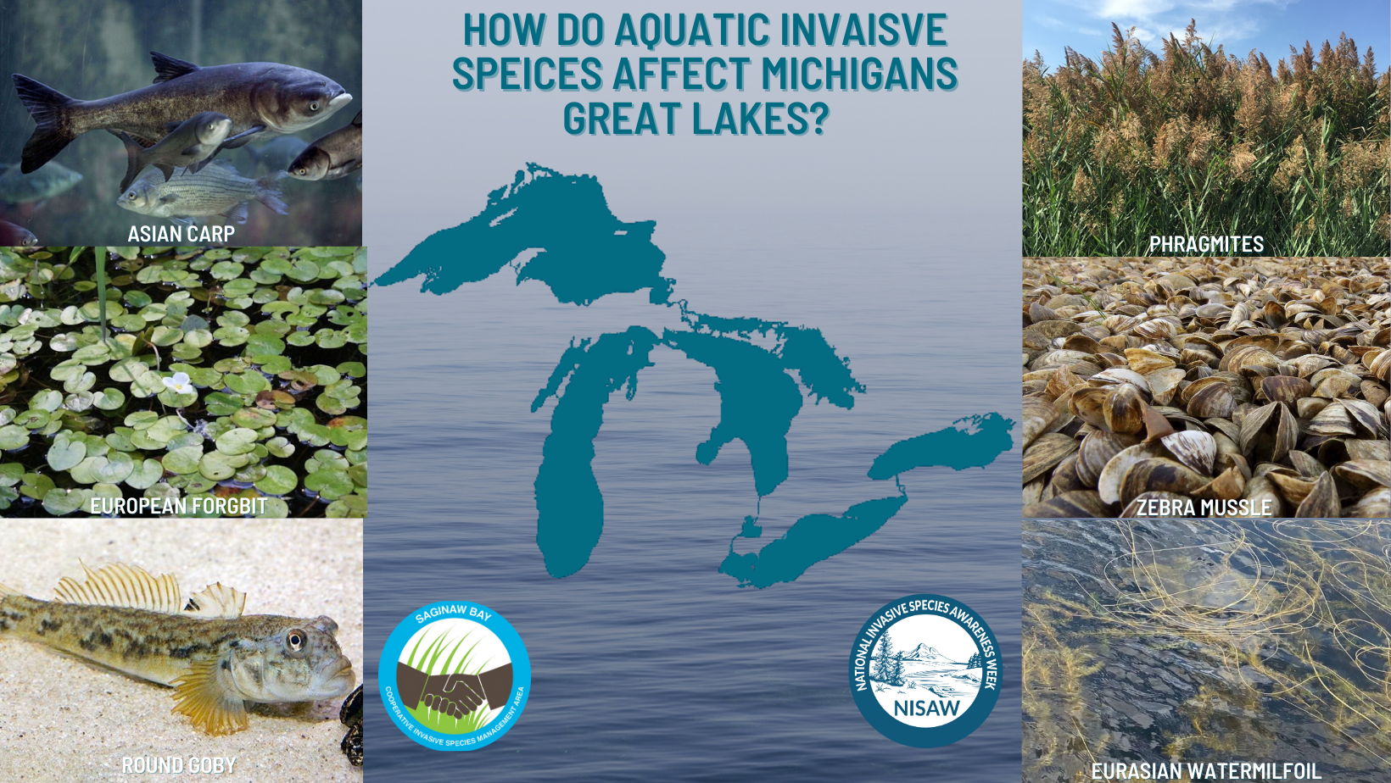

Post 2:
Decontamination
One of the most important ways to reduce the spread of invasive species is prevention: remove any invasive hitchhikers that could be attached to your equipment following aquatic activities. Boats and trailers can easily transport aquatic invaders from one waterbody to another. That's why it's crucial to properly inspect and decontaminate your boat before entering a waterbody and before you drive away from the waterbody. Making boat-cleaning a habit can help prevent the spread of harmful species and protect our valuable fishing and recreational resources from becoming infested. It's easy, effective, and essential for the health of our Great Lakes! #StopTheSpread #Clean Drain Dry #NationalInvasiveSpeciesAwarenessWeek

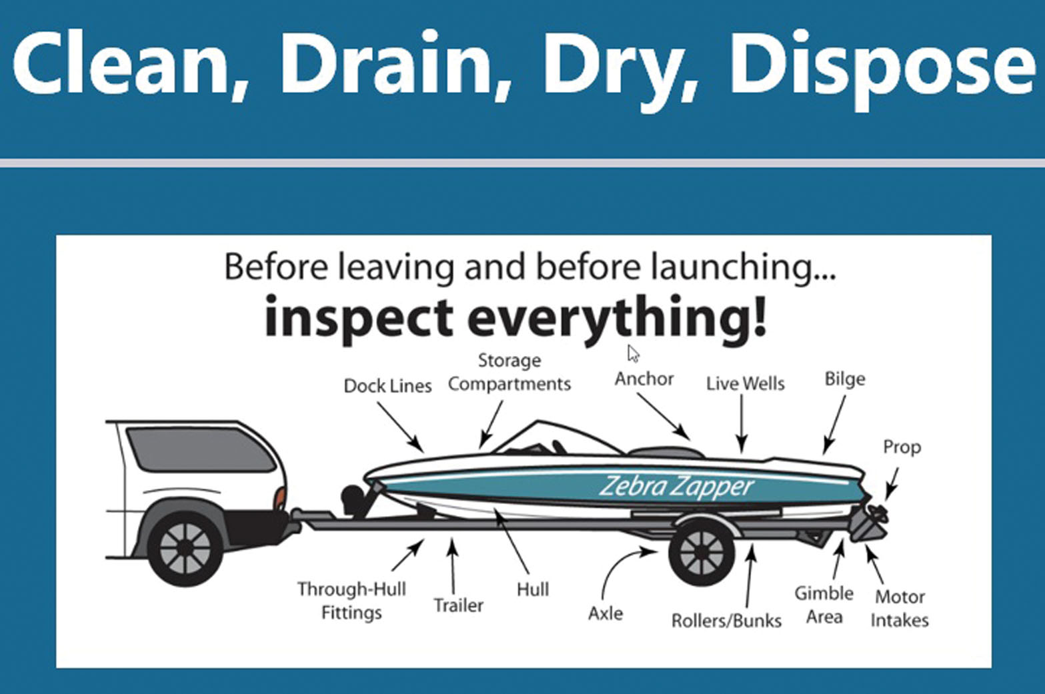
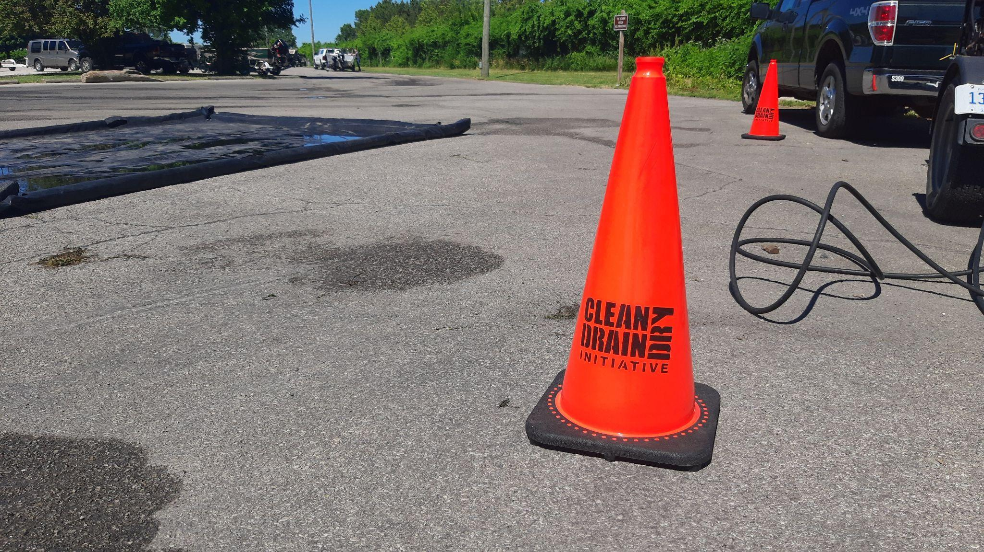

Post 3
Don’t Dump Bait
One of the most common ways for aquatic Invasive species to be introduced is through the dumping of live bait into our waterways. Live bait has the potential to introduce invasive species like the rusty crayfish, round goby and even zebra mussels. These species have the ability to outcompete native species, alter the ecosystem and cause harm to the fishing, boating and tourism industries. Dumping bait can increase the potential for new aquatic invaders. While these species may seem to be harmless vacationers that want to explore new waters they pester the locals by overstaying their welcome…

Always be on the lookout for these species and remember by properly disposing of live bait into the trash we can keep native species happy and safer from pesky aquatic invasive species!
#NationalInvasvieSpeciesAwarnessWeek #DontDumpBait

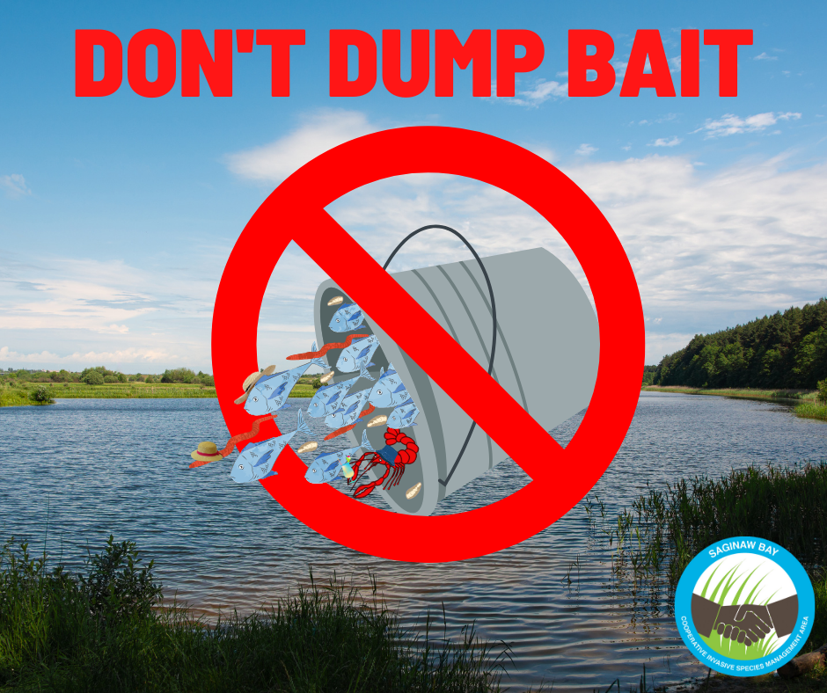

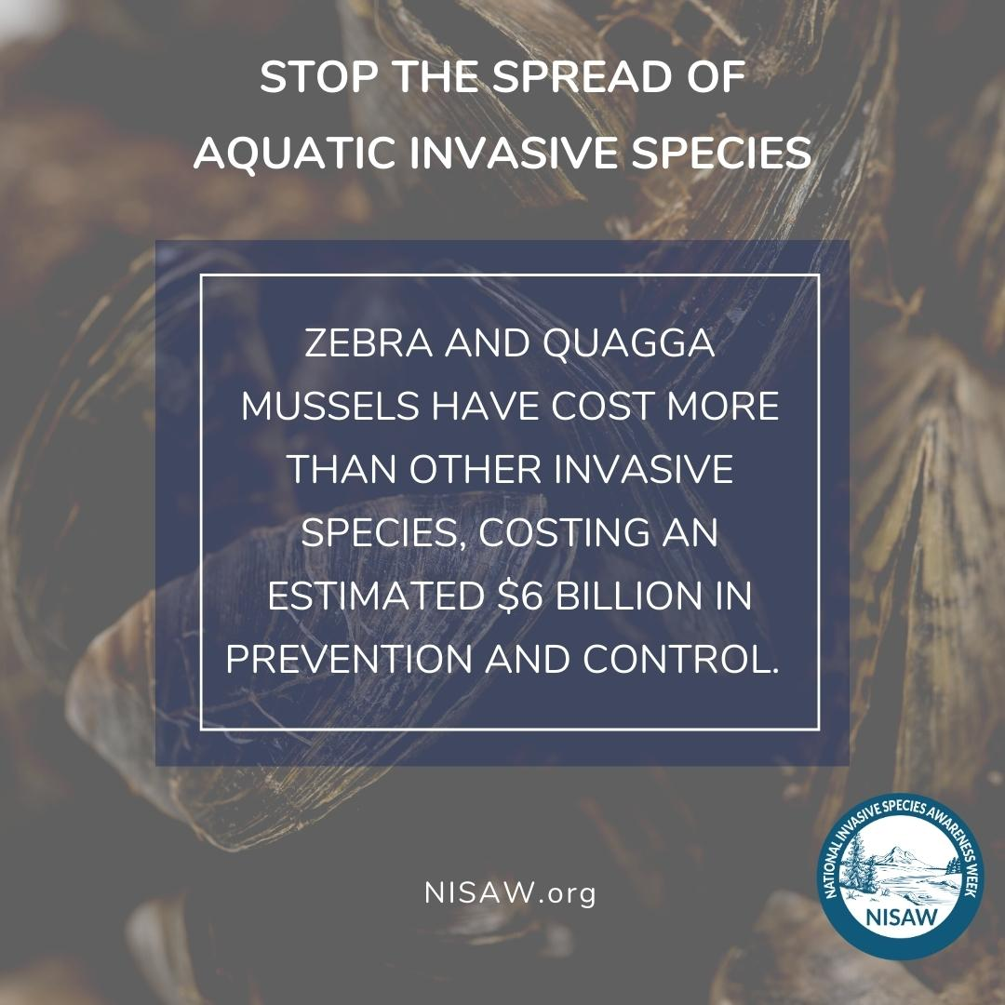

Wednesday February 28
Post 1:
Roadside Invaders/ Highways
Did you know humans are one of the main drivers of invasive species spread?
From the transportation of goods and equipment to the release of non-native pets, human activities have greatly contributed to the spread of invasive species around the world.
Unfortunately, because of constant transportation these invasive species can often be found along roadside and in ditches where they quickly establish themselves and compete with native species for resources. During your travels if you happen to see an invasive species along the road you can report your findings to MISIN. By using MISIN, you can help track the distribution of invasive species, assist with early detection and rapid response efforts, and contribute to the understanding of these species and their impact on the environment.
misin.msu.edu
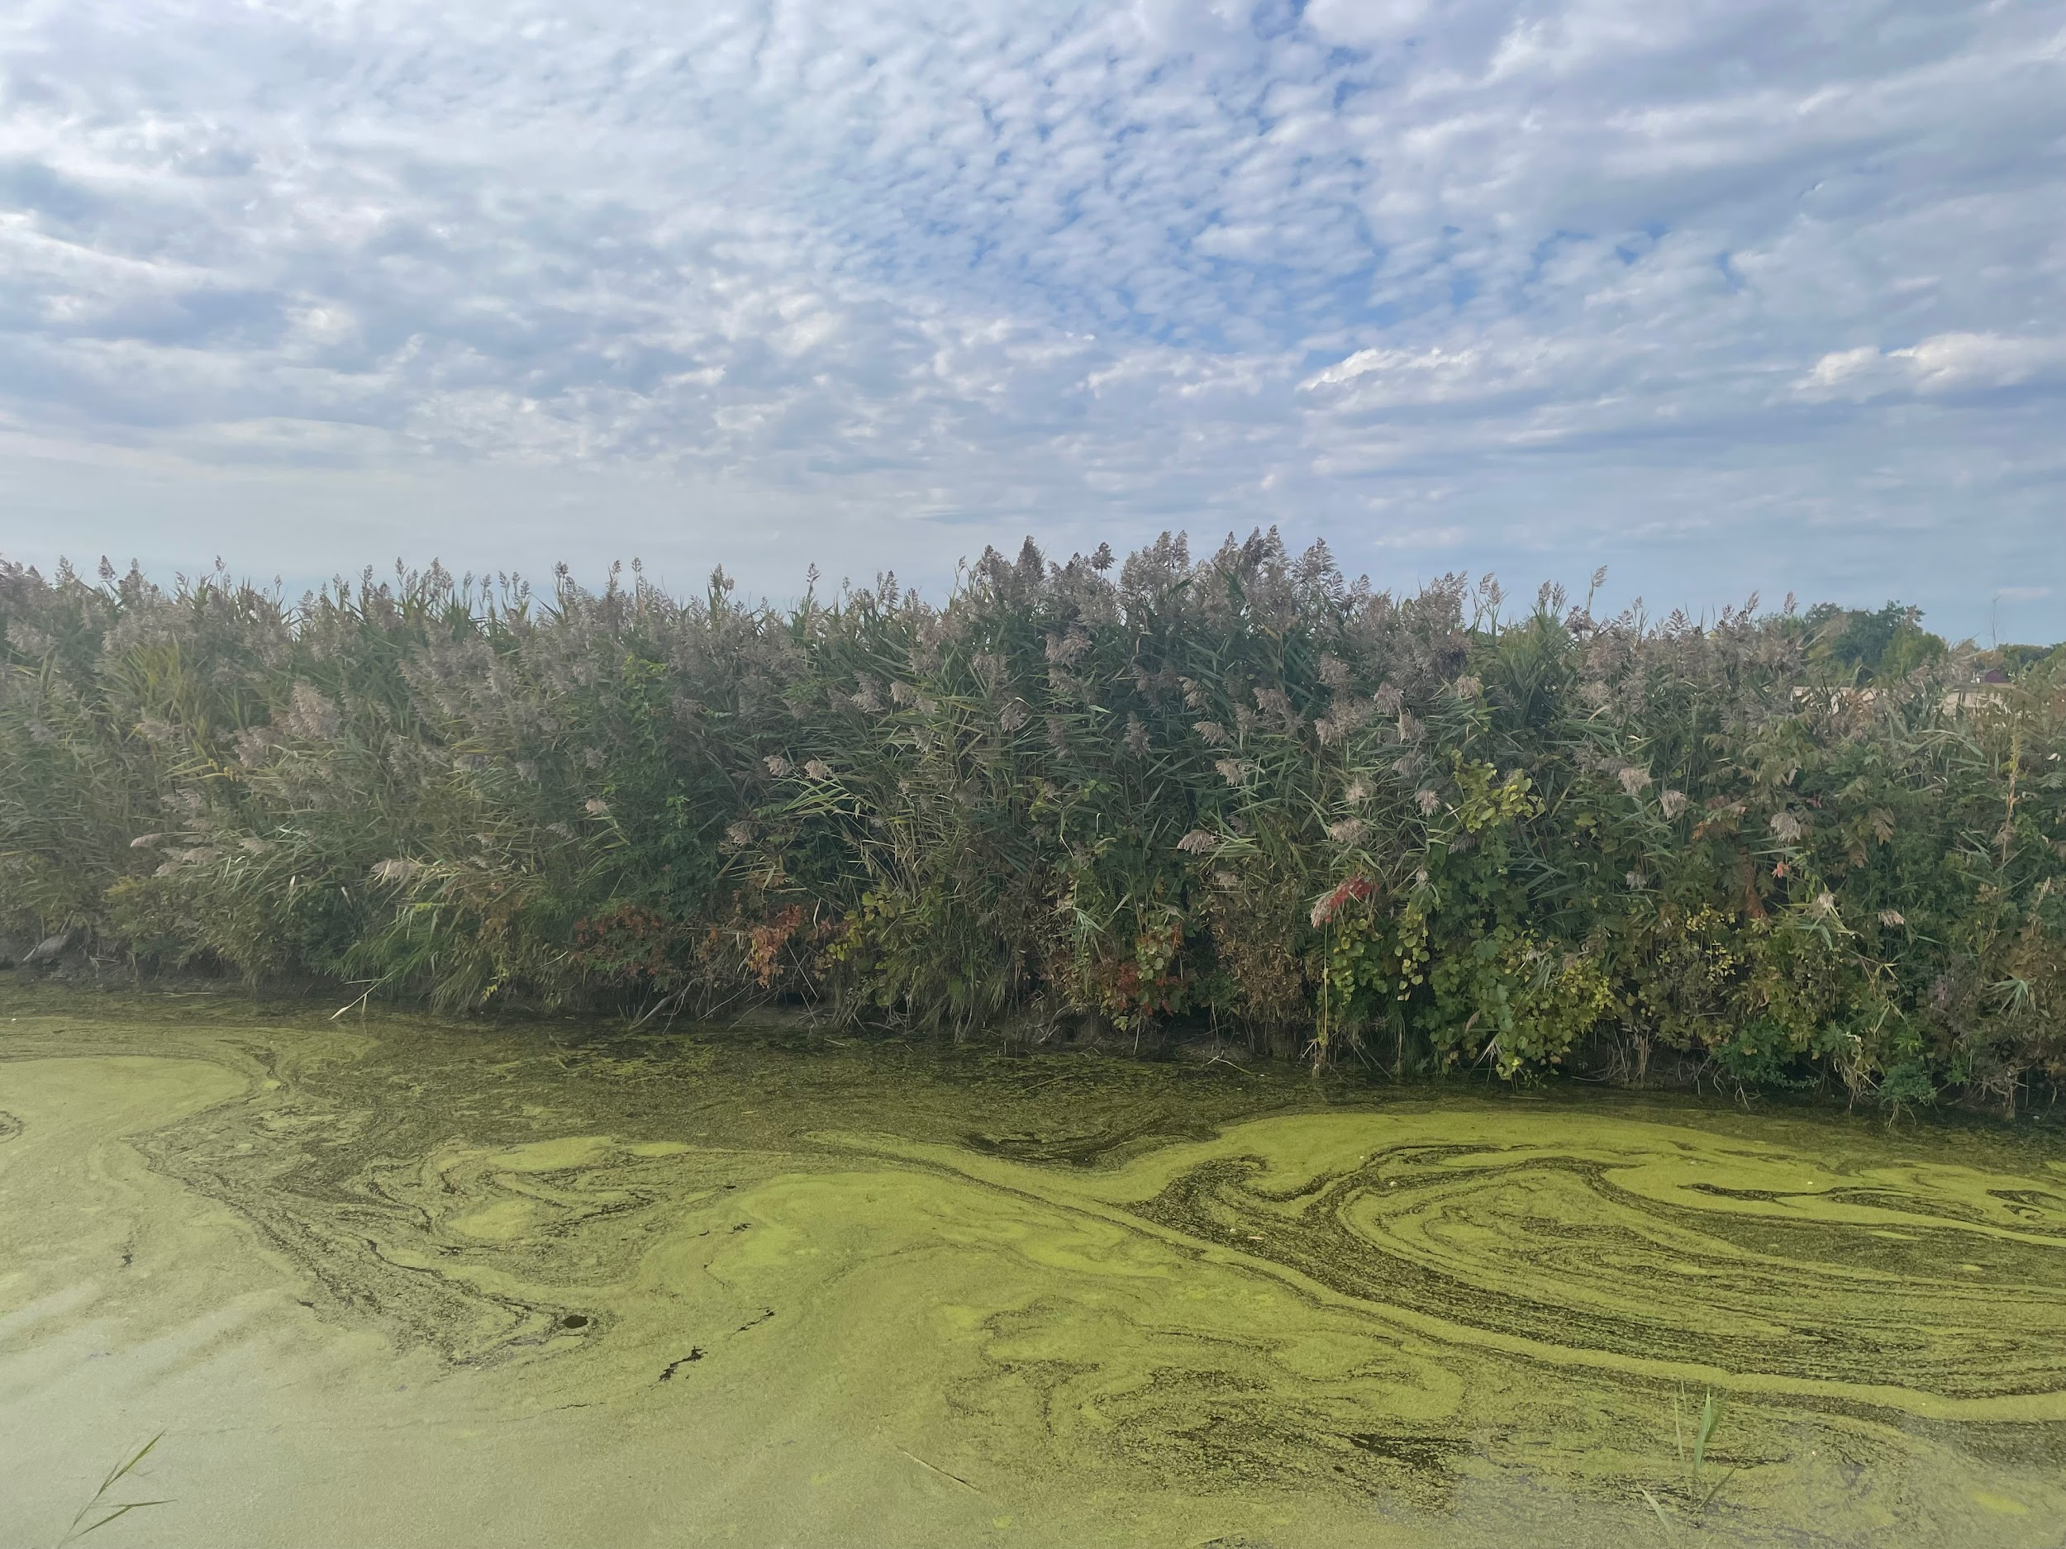

Thursday February 29
Post 1
Boot Brush Station
Attention all nature lovers and hikers: Did you know that using boot brushes before and after a hike can greatly help reduce the spread of invasive species? By brushing off any dirt or seeds from your shoes and gear, you can prevent the spread of these species to new locations. Some nature trails are lucky enough to have boot brush stations at the trailhead so you can easily brush off your shoes. Boot brush stations are a great resource in prevention of invasive species spread, programs such as Play, Clean, Go have boot brush stations available. Saginaw Bay CISMA has helped to install these at several partner locations. If you don’t have a boot brush at your favorite trail, fear not! Portable boot brushes or hoof picks are available and are easy to take anywhere you go. So, next time you hit the trails, remember to take a few extra seconds to clean your boots off and protect our natural habitats! #PlayCleanGO #NationalInvasiveSpeciesAwarenessWeek
More information on the boot brushes can be found at playcleango.org
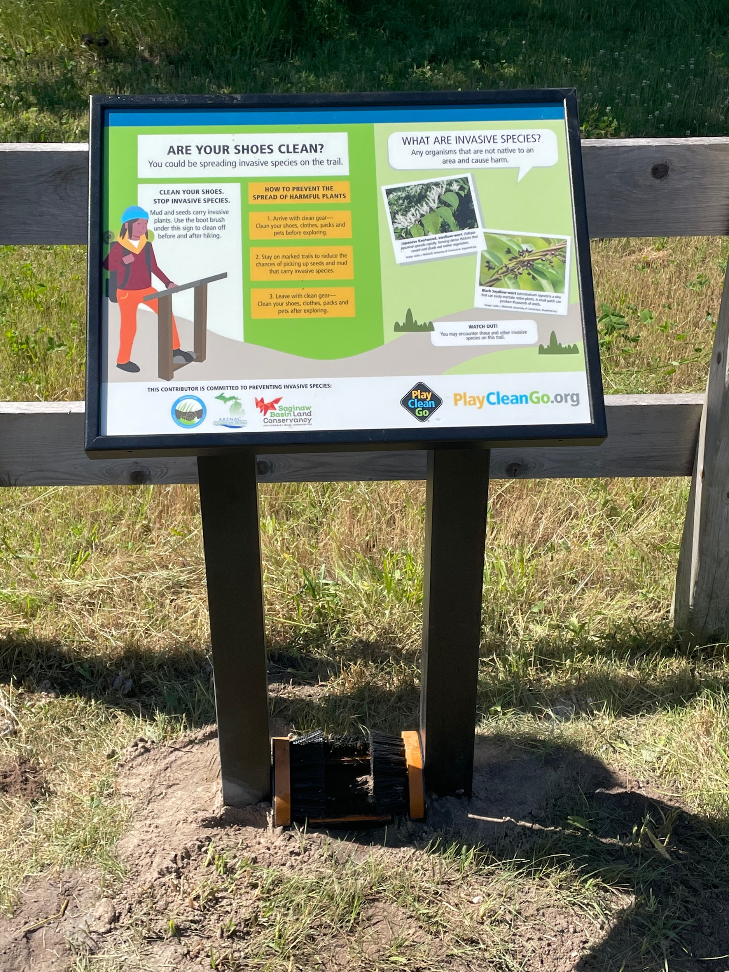

Post 2
Mobile Boat Wash
One great resource that can be used to prevent the spread of invasive species and show how it’s done is the mobile boat wash. Organizations such as MSU Extension have a mobile boat wash and crew, which travels throughout the state to educate on the importance of cleaning your boat. These sometimes appear at landing blitz events, which are held at multiple boat launches across the state. Landing blitz events allow boaters and anglers to receive a free boat wash after their day on the water. The mobile boat wash program led by MSU extension is a great way to inform and demonstrate how to properly clean off watercraft to prevent the spread of invasive species. Boat wash stations can also be installed at boat launches and are great infrastructure to help with invasive species prevention. If there isn't a boat wash station at your local launch, watercraft should still be inspected and cleaned for mud and plant material after leaving the water, all boat water should be drained, and unused bait should be disposed of.
#CleanDrainDry #NationalInvasiveSpeciesAwarenessWeek #LandingBlitz

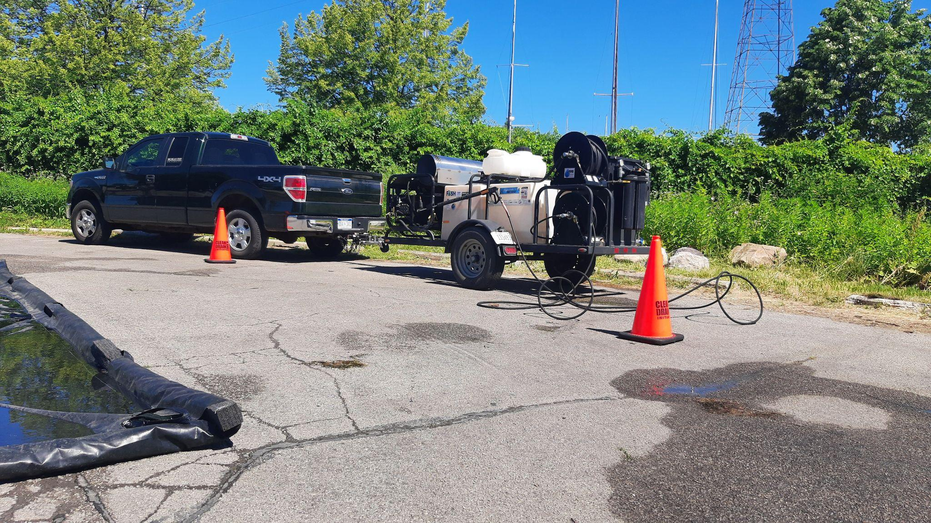

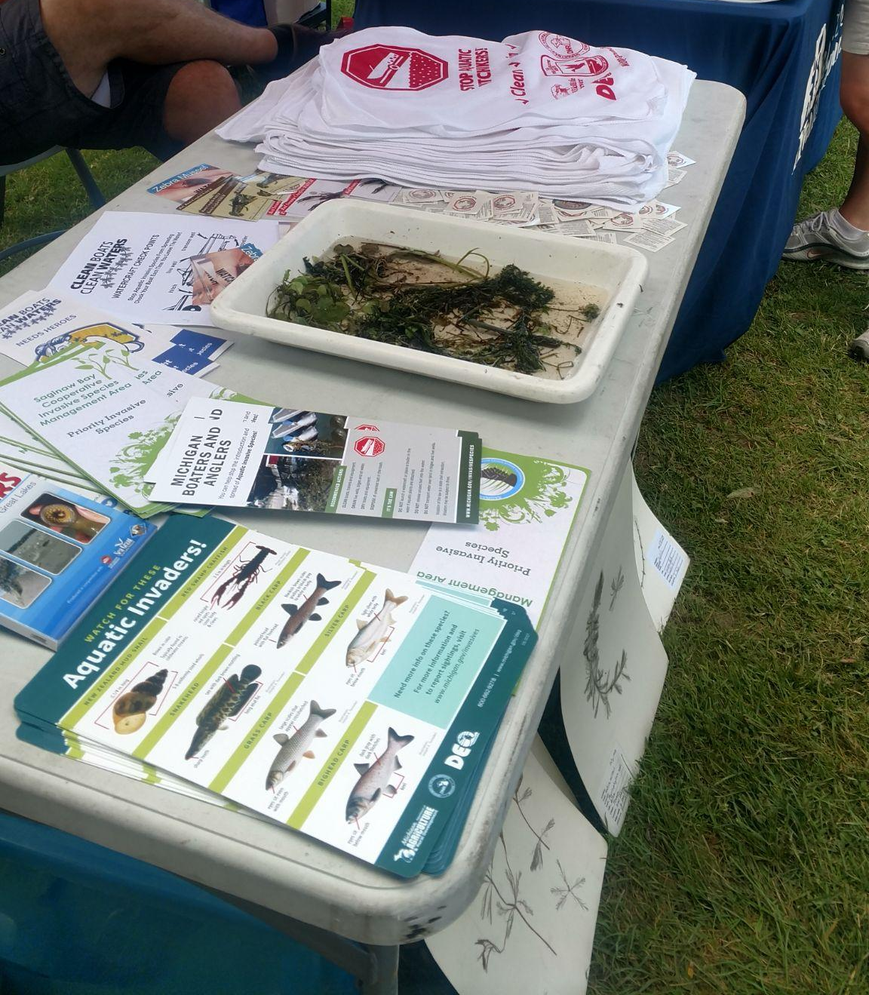

Friday March 1
Post 1:
Protect forest health
Michigan’s forested lands are a part of what makes our state unique and beautiful. Not only is it a source of biodiversity and recreational value, it is also vital to our economy. According to the State of Michigan forestry webpage, based on 2019 data it is estimated that “Michigan’s forest products industries provide direct employment to 42,000 people, leading to $13.4 billion in economic output.” It is important to keep an eye out for potential invaders that may decimate a species population. Early detection and rapid response to invaders could help prevent similar situations to the emerald ash borer and beech scale, which forever changed the composition of our forests. To learn more about how you can look out for early signs of forest pests, and to learn more about forest pests visit https://iforest.misin.msu.edu/ and https://www.nisaw.org/forest/
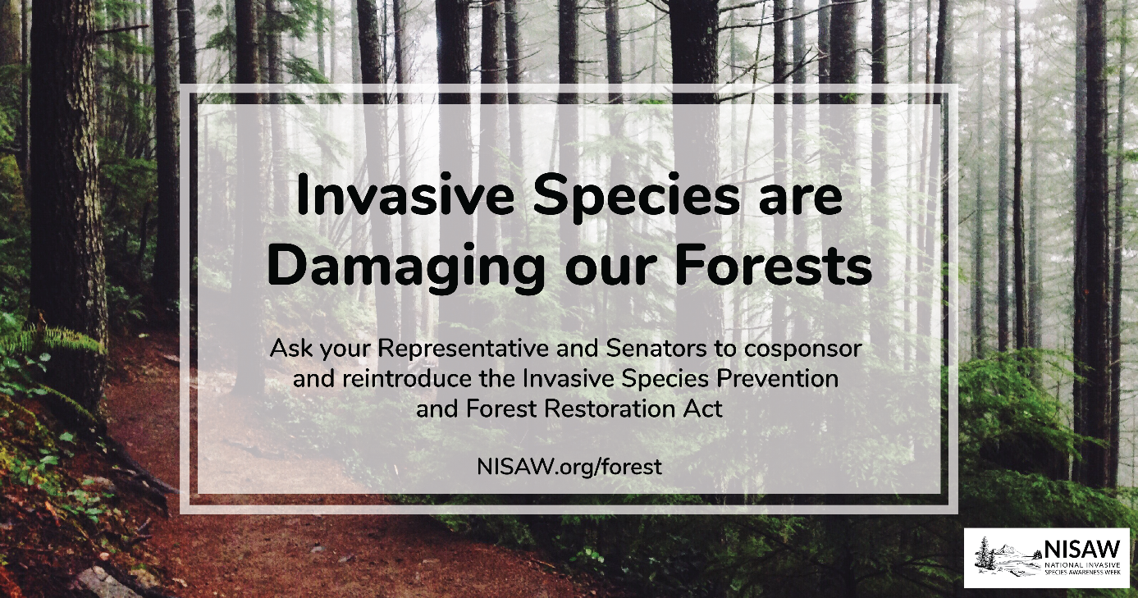

Post 2
Don't Move Firewood
Moving firewood can transport pests such as insects and diseases that are harmful to native trees and plants. Examples of invasive species that can hitch a ride on firewood include the emerald ash borer, Asian long-horned beetle, and gypsy moth. These pests can cause widespread damage to forests and disrupt ecosystems. By not moving firewood, we can help prevent the spread of these harmful species and protect our natural environment. We can do our part and buy firewood locally at our camping or picnic destinations! #NationalInvasiveSpeciesAwarenessWeek #ProtectOurForests #DontMoveFirewood
https://www.dontmovefirewood.org/
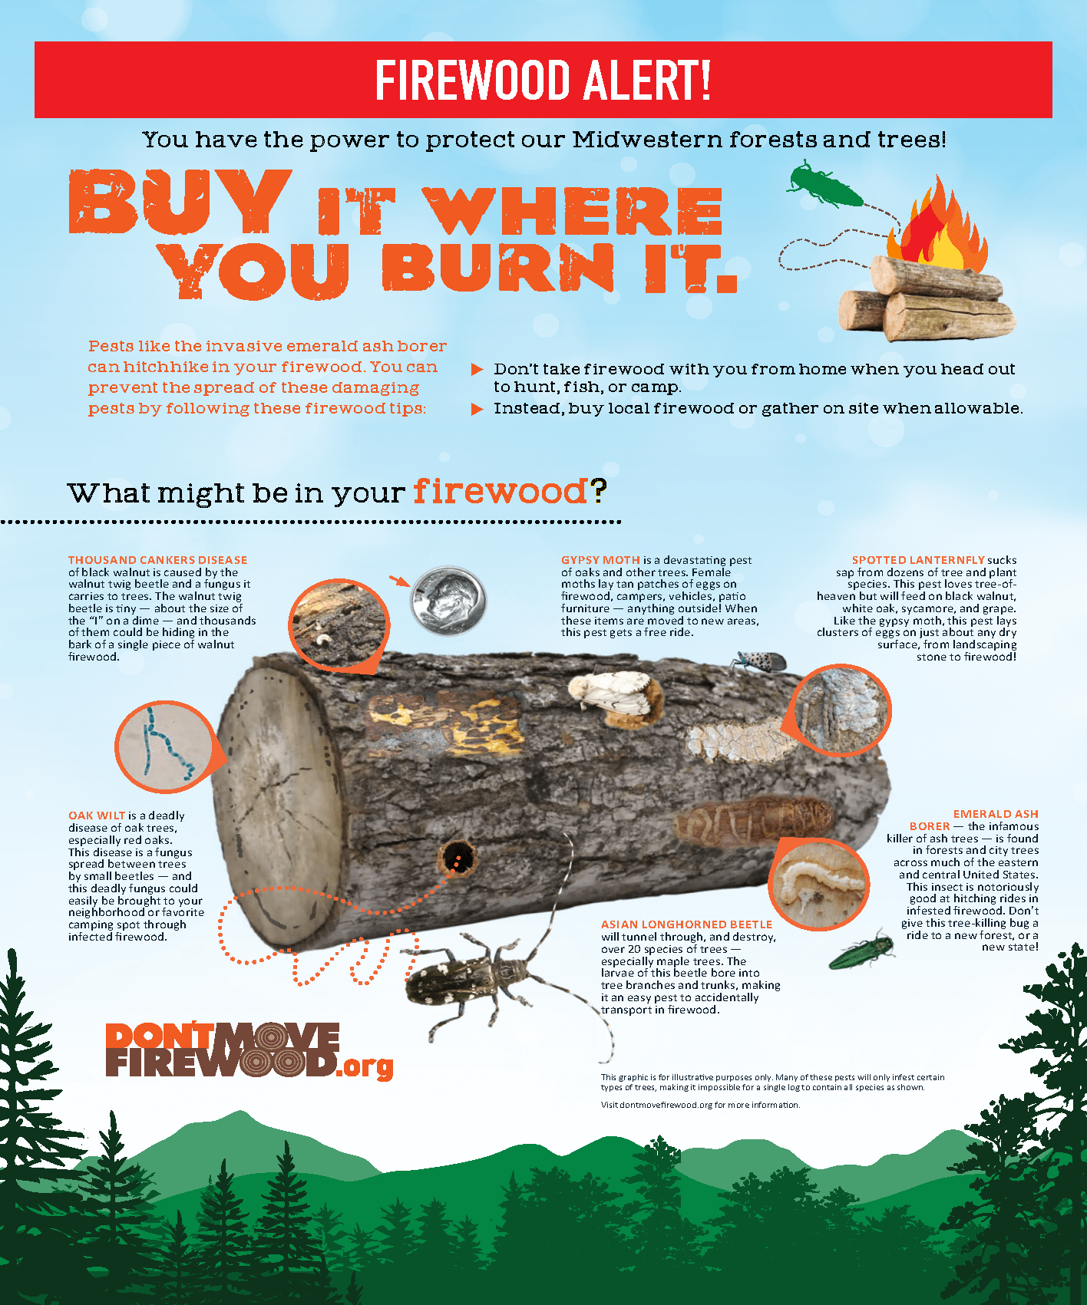

Saturday, March 2
Post 1:
Garden Alternatives
Looking for a way to add some greenery to your Michigan landscape while also protecting the environment? Consider swapping out invasive ornamental shrubs for native species! Michigan is home to a variety of beautiful native shrubs, including the Winterberry Holly, the Fragrant Sumac, and the Highbush Cranberry, just to name a few. Not only do these shrubs provide a stunning backdrop for your yard, but they also support more diverse pollinators and local wildlife to maintain a healthy ecosystem. Why not give these Michigan natives a try and make a difference in your own backyard!

A great resource for landscape alternatives can be found on the Woody Invasives of the Great Lakes Collaborative (WIGL) website listed below
https://woodyinvasives.org/landscape-alternatives/

Sunday, March 3
Post 1

Control Options
For the final day of National Invasive Species Awareness Week we would like to highlight some invasive species control methods. Throughout the week we have been discussing how to prevent the spread but what can you do if they are already established in your area?
Below are four types of control used to help manage invasive species:
- Mechanical control involves physically removing the invasive species through methods such as hand-pulling, cutting, or mowing. Plants such as garlic mustard and European frog-bit can be hand-pulled.
- Biological control involves the use of predators, parasites, or diseases to reduce the population of the invasive species. Species such as Japanese knotweed, garlic mustard, and purple loosestrife have specialist insects that target them.
- Chemical control involves the use of herbicides or pesticides to control the growth and spread of the invasive species. Most plants can be controlled using some method of herbicide treatment.
- Cultural control involves changing land use practices or modifying the habitat to make it less suitable for the invasive species to thrive. An example would be grazing goats on invasive buckthorns and multiflora rose.
It is important to note that different species respond differently to control methods. It is important to do some research to figure out what is the best control method for the invasive species you are dealing with. If you get overwhelmed by the amount of control options don’t hesitate to reach out to your local CISMA for best practices or you can visit michigan.gov/invasives to access best management practice guides.

Post 2:
NISMA Wrap Up
National Invasive Species Awareness Week may be coming to a close, but our commitment to protecting our environment and ecosystems from harmful invasive species continues. Invasive species are a growing threat to the health and well-being of our ecosystems and communities, and raising awareness is a critical step in preventing their spread. Your efforts in sharing information and educating others make a significant impact in raising awareness about the issue and taking action to protect our environment.

